

Syrian Private University
Faculty Of Artifical Intelligence Engineering

BI VOICE AGENT

Prepared by

Massa Mohammad Jamal Nasri
Ayman Naeem Alkotyfan

Supervisors

Eng.Anas Abdualziz

Academic Year: 2025–2026

الجامعة السورية الخاصة
كلية هندسة الذكاء الصنعي

مساعد صوتي لذكاء الأعمال

اعداد

ماسة محمد جمال نصري
أيمن نعيم القطيفان

اشراف

المهندس أنس عبد العزيز

السنة الدراسية 2025-2026

Supervisor certification
I certify that the preparation of this project entitled BI Voice Agent, prepared by Ayman Al-kotyfan and Massa Nasri, was carried out under my supervision in the Department of Software Engineering and Artificial Intelligence as part of the requirements for obtaining a Bachelor's degree at the College of Artificial Intelligence Engineering.

Name | Role / Position | Signature | Date
Eng. AnasAbdulaziz | AcademicSupervisor | ______________________ | ____ / ____ / 2026

Abstact

BI Voice Agent is an intelligent Business Intelligence (BI) system designed to enable users to interact with analytical databases using natural spoken language instead of traditional query interfaces. The primary objective of the system is to simplify data analysis for non-technical users by transforming voice-based questions into actionable insights in real time.
The system adopts a modular, service-oriented architecture that integrates Speech-to-Text, Natural Language Understanding, SQL generation, data processing, and visualization layers. User voice input is first transcribed using an automatic speech recognition module, after which the resulting text is analyzed to determine the intent and classify the query type. Analytical questions are then converted into structured SQL queries compatible with analytical databases, while non-analytical queries are filtered out early in the pipeline.
To support large-scale and real-time data analytics, BI Voice Agent relies on an ETL (Extract, Transform, Load) pipeline built on a distributed architecture. Data is ingested from heterogeneous sources, processed through streaming and transformation services, and stored in an analytical data warehouse optimized for fast querying. The system continuously monitors ETL execution states and metadata to ensure reliability, consistency, and accurate reporting.
The final results are presented to the user in the form of dynamic charts and dashboards, allowing seamless exploration of insights without requiring technical knowledge of SQL or BI tools. By combining voice interaction, data engineering, and intelligent query generation, BI Voice Agent provides an intuitive, scalable, and efficient solution for modern business intelligence applications.

الملخص

BI Voice Agent هو نظام ذكاء أعمال (Business Intelligence) ذكي يهدف إلى تمكين المستخدمين من التفاعل مع قواعد البيانات التحليلية باستخدام اللغة الصوتية الطبيعية بدلاً من واجهات الاستعلام التقليدية. يهدف المشروع بشكل أساسي إلى تبسيط عملية تحليل البيانات، خاصة للمستخدمين غير التقنيين، من خلال تحويل الأسئلة الصوتية إلى نتائج تحليلية واضحة وبشكل فوري.
يعتمد النظام على بنية معمارية معيارية قائمة على الخدمات، حيث يتم دمج وحدات تحويل الصوت إلى نص، وفهم اللغة الطبيعية، وتوليد استعلامات SQL، ومعالجة البيانات، وعرض النتائج. تبدأ العملية باستقبال صوت المستخدم وتحويله إلى نص، ثم تحليل النص لاستخراج نية السؤال وتحديد نوعه. في حال كان السؤال تحليليًا، يتم تحويله تلقائيًا إلى استعلام SQL متوافق مع قواعد البيانات التحليلية، بينما يتم إيقاف الأسئلة غير التحليلية في مراحل مبكرة من النظام.
لدعم تحليل البيانات الضخمة والزمن الحقيقي، يعتمد النظام على خط أنابيب ETL (الاستخلاص، التحويل، التحميل) مبني على بنية موزعة. يتم جلب البيانات من مصادر متعددة، معالجتها عبر خدمات بث وتحويل، ثم تحميلها إلى مستودع بيانات تحليلي عالي الأداء. كما يقوم النظام بتتبع حالات تنفيذ الـ ETL والبيانات الوصفية لضمان الاستقرار والدقة والموثوقية.
في المرحلة النهائية، يتم عرض النتائج للمستخدم على شكل رسوم بيانية ولوحات معلومات تفاعلية، مما يتيح استكشاف البيانات بسهولة دون الحاجة لمعرفة تقنية مسبقة بـ SQL أو أدوات ذكاء الأعمال. يجمع BI Voice Agent بين التفاعل الصوتي، وهندسة البيانات، والذكاء الاصطناعي ليقدم حلاً حديثًا، مرنًا، وقابلًا للتوسع في مجال ذكاء الأعمال.

فهرس

Chapter 1 Introduction

1. Introduction
This chapter provides a general introduction to the BI Voice Agent project and establishes the foundation for the rest of the report. It begins by presenting the overall context and motivation behind the project, highlighting the challenges associated with traditional Business Intelligence systems. The chapter then defines the problem addressed by the project and clearly states the main objectives to be achieved.
In addition, this chapter introduces the proposed system at a high level, explaining its main components and general workflow without going into technical details. Finally, the chapter outlines the structure of the report and describes the content of each subsequent chapter to guide the reader through the document.
2. Problem Statement
Despite the availability of powerful BI platforms, many organizations face difficulties in enabling users to effectively analyze data. The main challenges include the complexity of writing SQL queries, the need for technical expertise to interpret dashboards, and the lack of natural interaction with analytical systems. These limitations slow down decision-making processes and restrict access to data insights to a limited group of technical users.
Additionally, traditional BI systems do not provide seamless integration between voice-based interaction and real-time analytical querying. There is also a lack of intelligent pipelines that can automatically validate, process, and monitor analytical data while maintaining scalability and reliability.
Therefore, there is a need for a system that enables users to query analytical databases using voice commands, automatically interpret user intent, generate correct SQL queries, and present results in an understandable and visual form.
3. Project Objective
The main objective of the BI Voice Agent project is to design and implement an intelligent voice-driven Business Intelligence system that simplifies data analysis and enhances accessibility for users of all technical levels.
The specific objectives of the project include:

- Enabling voice-based interaction with analytical databases.
- Automatically converting spoken questions into structured SQL queries.
- Classifying user questions to determine whether they are analytical or non-analytical.
- Integrating a scalable ETL pipeline for data ingestion, transformation, and loading.
- Providing real-time analytical results through visual dashboards and charts.
- Ensuring system scalability, reliability, and modularity.

4. Proposed System
The proposed system is a multi-layered, service-oriented architecture that integrates voice processing, intelligent query generation, and data analytics. The system begins by capturing the user’s voice input, which is converted into text using a speech recognition module. The text is then processed to extract intent and determine the type of query.
For analytical queries, the system generates SQL statements compatible with the analytical data warehouse. The data is processed through an ETL pipeline that ensures data consistency and quality. Finally, the query results are visualized using interactive charts and dashboards.
The architecture is designed to be modular, allowing each component to operate independently while maintaining seamless communication between services.

5. Report Organization
The report is structured as follows:
- Chapter 1: Introduction
- Chapter 2: Basic Concepts and Reference Study
- Chapter 3: Project Management
- Chapter 4: System Analysis
- Chapter 5: System Design
- Chapter 6: Practical Implementation
- Chapter 7: Report Overview

6. Summary
This chapter presented an overview of the BI Voice Agent project, including the motivation behind the system, the problem it addresses, the project objectives, and the proposed solution. It also outlined the structure of the report and provided a foundation for the technical and analytical discussions in the following chapters.

Chapter 2: Basic Concepts and Reference Study

I. Reference Study of Interactive AI Powered Business Intelligence Tools

1. Introduction

This chapter provides a foundation for understanding the BI Voice Agent system by exploring the fundamental concepts and reviewing related studies in the field of intelligent business analytics. It examines essential terminology, key principles, and core technologies such as Business Intelligence systems, voice-based interaction, natural language processing, and data analytics pipelines.
The chapter aims to present an overview of AI-driven and natural language–based business intelligence platforms, along with insights from existing solutions and research studies. These references help identify current capabilities and limitations in the field and provide guidance for the design and development of the proposed BI Voice Agent system.

2. Fundamental Concepts
This section introduces the core concepts required to understand the design and functionality of the BI Voice Agent system.
- Business Intelligence (BI):
Business Intelligence refers to technologies and processes used to collect, integrate, analyze, and visualize data to support decision-making. Traditional BI systems rely heavily on dashboards, predefined reports, and structured queries such as SQL.
- Natural Language Querying:
Natural Language Querying allows users to interact with data systems using human language instead of formal query syntax. This approach improves accessibility, especially for non-technical users, but introduces challenges such as ambiguity, context understanding, and intent recognition.
- Voice-Based Interaction:
Voice-based interfaces extend natural language querying by enabling spoken input. Such systems require accurate speech-to-text processing and must handle variations in pronunciation, accents, and query structure.
- Natural Language to SQL (NL2SQL):
NL2SQL systems automatically translate user questions into structured SQL queries. These systems must correctly map user intent to database schemas, tables, and columns while ensuring query correctness and security.
- ETL and Data Pipelines:
ETL (Extract, Transform, Load) pipelines are responsible for ingesting data from multiple sources, cleaning and transforming it, and loading it into analytical data stores. Scalable and monitored ETL pipelines are essential for real-time and enterprise-level analytics.
- Analytical Data Warehouses:
Analytical databases are optimized for read-heavy workloads and large-scale aggregations. They support fast execution of complex analytical queries and are commonly used in modern BI systems.
Together, these concepts form the technical foundation upon which voice-driven and AI-powered business analytics systems are built.
- Large Language Models (LLMs)
LLMs are advanced AI models trained on large-scale textual data to understand and generate human-like language. In BI Voice Agent, LLMs play a key role in interpreting user intent, converting natural language queries into structured representations, and assisting in SQL generation.
- Apache Kafka (Data Streaming)
Kafka is a distributed event-streaming platform used for building scalable and fault-tolerant data pipelines. It enables asynchronous communication between ETL components, ensuring reliable data flow and system decoupling.
- ClickHouse (Analytical Data Warehouse)
Is a high-performance column-oriented analytical database optimized for large-scale read-heavy queries. It supports fast aggregation and real-time analytics, making it suitable for BI applications.
- Metabase (Data Visualization)
Is an open-source business intelligence tool used for visualizing analytical query results. It allows users to explore data through dashboards and charts without requiring SQL expertise.
- LangChain / LangGraph (AI Orchestration)
Are frameworks designed to manage and orchestrate interactions between large language models and external tools. They enable structured reasoning flows, multi-step decision-making, and modular AI pipelines.
3. Literature Review for the system

-1ThoughtSpot – Interactive AI-Powered Business Analytics Platform

1.1Platform Description
ThoughtSpot is an AI-powered business analytics platform that allows users to query data through a simple, search-like interface. Employees can ask questions in natural language and instantly get visual or tabular answers without SQL skills.
It features SpotIQ for automatic pattern and anomaly detection, and SearchIQ for natural language and voice queries that reveal hidden insights in large datasets.
Powered by the in-memory Falcon engine, ThoughtSpot delivers fast, real-time analytics at enterprise scale, with API and SDK integrations that embed its capabilities into other business applications and dashboards.

1.2System Actors
The platform serves multiple roles within an organization:
- Non-technical users (e.g., sales, marketing, and business managers) can access analytics easily through an intuitive search-based interface.
- Data analysts and data engineers prepare and model the data, design Worksheets, and define relationships between tables to ensure accurate results.
- System administrators (IT Managers) integrate ThoughtSpot with data sources and manage security and permissions, with support for identity systems like Okta and Azure AD.
- Developers use ThoughtSpot APIs to embed its analytical capabilities into other applications or to build custom interactive dashboards.

1.3Core Functional Requirements
ThoughtSpot relies on several core functional requirements to ensure high performance and usability within enterprise environments:
- Data Integration: Connects to various data sources such as cloud warehouses, databases, and Excel files.
- Data Modeling: The technical team prepares structured data models (e.g., Star Schema) for efficient querying.
- Real-Time Queries: Runs live queries on connected data without permanent storage, using in-memory caching for speed.
- High Performance: Requires a fast data warehouse or cloud setup to utilize the Falcon engine effectively.
- Multi-Device Access: Accessible via web and mobile interfaces for flexible, on-the-go analytics.
- Natural Interaction: SearchIQ enables voice and natural language queries for intuitive exploration.
- APIs and SDKs: Allows embedding analytics and extracting results programmatically into other systems.
- Deployment Flexibility: Offered as a managed cloud service or on-premises installation (AWS, GCP, Azure).
- Security & Compliance: Uses encrypted, VPN-secured connections and adheres to SOC 2, ISO 27001, and GDPR standards.
.
-2Databricks AI/BI Genie – Natural Language Business Intelligence Platform

2.1 Platform Description
Databricks AI/BI Genie is a feature within the Databricks platform that allows users to ask questions about their data in natural language within the Lakehouse environment. Genie interprets business questions, converts them automatically into SQL queries, and displays the results as interactive tables or charts.
It is powered by Large Language Models (LLMs) customized to each organization’s data and terminology. As a compound AI system, Genie can ask clarifying questions and generate accurate analyses, acting as a virtual business intelligence analyst that delivers instant insights.

2.2 System Actors
- Non-technical business users: Ask questions and receive instant insights without writing SQL queries.
- Data analysts and engineers: Configure the Genie Space and provide contextual definitions and examples to train the model.
- System administrators: Integrate Genie with data sources via Unity Catalog, manage security, and ensure sufficient computing resources.
- Developers: Embed Genie’s capabilities into external applications using APIs.

2.3 Core Functional Requirements
- Structured data organization: Data must be registered in Unity Catalog with clear descriptions and defined relationships.
- Rich metadata and context: Add organizational terms, KPIs, and definitions within Genie Space to improve understanding.
- SQL Warehouse connection: Execute read-only SQL queries without modifying source data.
- Adequate computing resources: Ensure fast query execution and scalability for multiple users.
- Integration with LLMs: Genie operates using managed models like Dolly or Azure OpenAI.
- Security and governance: Enforces Unity Catalog policies for access control and data privacy.
- Performance monitoring: Tracks user queries and feedback to continuously improve accuracy and reliability.

3-Microsoft Power BI – Interactive Business Intelligence Platform by Microsoft

3.1 Platform Description
Microsoft Power BI is a leading cloud-based business intelligence platform that helps users collect, transform, and visualize data through interactive dashboards and reports. It includes Power BI Desktop for report creation and Power BI Service for online sharing.
With Q&A and Copilot, users can analyze data and generate insights using natural language, making analytics accessible even to non-technical users.

3.2 System Actors
- Admin: Manages the workspace, security, and data connections.
- Creator: Builds models and reports using Power Query and DAX.
- Contributor: Edits and updates shared reports.
- Viewer: Consumes reports and dashboards for decision-making.
- Stakeholders: Define data requirements and use insights strategically.

3.3 Core Functional Requirements
- Data Connectivity: Links to on-premises and cloud sources (SQL, Azure, Excel, etc.).
- Flexible Query Modes: Supports Import and DirectQuery for real-time or cached data.
- Data Modeling: Cleans and structures data via Power Query using Star Schema.
- In-memory Engine: Uses VertiPaq for high-speed data compression and analytics.
- Secure Gateway: Syncs on-premises data with cloud services safely.
- Licensing & Capacity: Requires Pro or Premium licensing for enterprise performance.
- Integration: Embeds reports via APIs and connects with Azure, Office 365, and Teams.
- Security: Applies encryption and Row-Level Security (RLS) for controlled access.
- Performance: Scales efficiently through optimized models and Premium capacity.

-4Vanna.AI – Open-Source Interactive Data Intelligence Framework

4.1Platform Description
Vanna.AI is an open-source framework for building AI agents that analyze data through natural language. It allows users to ask questions directly to a database without writing SQL, translating queries automatically using Large Language Models (LLMs).
Vanna employs the Retrieval-Augmented Generation (RAG) approach, enhancing accuracy by providing contextual knowledge such as database schema, table descriptions, and relationships. It returns interactive results as tables or visualizations using libraries like Plotly, enabling a conversational and intuitive data analysis experience.

4.2System Actors
- End User: Non-technical employee or analyst who interacts with the system through a chat interface to retrieve insights.
- Developer/Data Engineer: Integrates Vanna with databases and configures connections to AI models and data sources.
- Data Expert: Trains the model on database structure, adds examples, and improves accuracy through feedback.
- System/Security Administrator: Manages API keys, access permissions, and ensures queries are executed securely in read-only mode.

4.3Core Functional Requirements
- Structured Database: Supports relational and modern databases such as PostgreSQL, MySQL, SQLite, Snowflake, and BigQuery.
- Reliable Connectivity: Requires accessible JDBC/SQL connections between Vanna and the target database.
- Well-Documented Schema: Tables and fields should be clearly defined to enhance training and query accuracy.
- Python Environment: Install the Vanna package and link it to both the database and the chosen language model.
- LLM Integration: Compatible with GPT-4, Claude, or locally hosted open-source models.
- Vector Database (optional): Used for RAG context retrieval via Pinecone, Chroma, or FAISS.
- Access Control & Security: Operates with read-only permissions and user identity tokens for authorization checks.
- Flexible Interface: Deployable as a web app (Flask/Streamlit) or integrated with tools like Slack or Teams.
- Cloud Option: Vanna Cloud provides monitoring, query logging, and secure connectivity to enterprise data sources.

-5Sequel.sh – AI-Native Business Intelligence Platform

-1Platform Description
Sequel.sh is a modern AI-native BI platform built from the ground up for natural interaction with data. It allows users to ask questions in plain English and instantly receive visual, data-driven answers—without needing SQL knowledge.
The platform translates questions into optimized SQL queries executed directly on live databases, ensuring real-time insights. Sequel automatically understands database schemas, enabling accurate interpretation without manual setup.
Its chat-style interface lets users explore, save, and share insights within collaborative Workspaces, with smart features like automated insights and interactive trend analysis.

5.1System Actors
- Business Users: Product managers, marketers, and analysts who ask questions and interact with visual results through an intuitive chat interface.
- Data Analysts and Experts: Use the built-in SQL editor to review or fine-tune AI-generated queries for higher accuracy.
- Data Engineers and Administrators: Connect Sequel to company databases securely, define user roles, and manage permissions.
- Security Teams: Monitor access, encryption, and activity logs to ensure compliance and data privacy.

5.2Core Functional Requirements
- Database Connectivity: Supports PostgreSQL, MySQL, and SQLite for direct querying without data migration.
- Secure Connection: Requires SSL-encrypted communication and read-only database credentials.
- Optimized Performance: Databases should be indexed and tuned for instant, real-time query responses.
- Cloud Setup (SaaS): Operates fully in the cloud with simple initial configuration and workspace creation.
- Workspace Collaboration: Enables team environments with role-based access (Viewer / Member).
- Single Sign-On (SSO): Supports OAuth or SAML for enterprise identity integration.
- Hybrid Deployment Option: Can use a local agent within the client’s cloud to keep data within secure boundaries.
- AI Model Integration: Uses built-in language models to convert natural language to SQL automatically.
- Usage & Cost Management: Tracks queries and data volume to manage subscription limits effectivel

II. Comparative Analysis of AI-Powered Interactive BI Platforms

Criterion | ThoughtSpot | Databricks AI/BI Genie | Microsoft Power BI | Vanna.AI | Sequel.sh | BI Voice Agent (Our Project)
Platform Type | AI-driven search-based BI platform | AI assistant inside Databricks Lakehouse | Traditional BI with AI enhancements | Open-source AI analytics framework | AI-native BI for natural querying | Voice-controlled BI assistant for speech-to-dashboard automation
Main Purpose | Natural language search and instant analytics | Natural language analytics in Databricks | Create and share dashboards and reports | Query databases via natural language | Provide instant AI-powered SQL insights | Convert voice input → SQL → dashboards automatically
Core Mechanism | NLP → SQL → Falcon engine | LLMs generate SQL with contextual understanding | Copilot Q&A + BI visualization | LLM + RAG → SQL | English → optimized SQL on live data | Whisper STT → LLM Text-to-SQL → ClickHouse → Metabase dashboards
AI Capabilities | SpotIQ, SearchIQ | Context-aware LLMs (Compound AI) | Copilot + Q&A | LLMs with RAG | Built-in LLM SQL translation | Speech recognition + LLM SQL generation + auto visualization
Primary Users | Managers & non-technical users | Analysts in Databricks | Analysts & employees | Developers & analysts | Business users & engineers | Managers, analysts, and business users who prefer voice commands
Additional Roles | Admins, devs, engineers | Domain experts, governors | Admin, Creator, Viewer | Developers, admins | Data engineers, security officers | Manager, Data Analyst, System Admin (defined in our system)
Deployment Model | Cloud / On-Prem | Databricks cloud | Cloud or Desktop | Local / Cloud | SaaS cloud or local agent | Local deployment using Docker + Kafka + ClickHouse + Flask
Data Preparation | Worksheets, Star Schema | Genie Space configuration | Power Query, Star Schema | Metadata training, schema enrichment | Auto schema detection | ETL pipeline (CSV → JSON → Kafka → ClickHouse) with cleaning & structuring
Security & Governance | SSO, Encryption | Unity Catalog | Encryption, RLS | Token identity checks | SSL, activity logs | Role-based access + workspace isolation + secure DB access
Integration Capabilities | APIs & SDKs | APIs for Teams | Power BI Embedded | Slack, Teams, Jupyter | Export & integrations | Kafka streaming, ClickHouse, Metabase, Flask APIs
User Interface | Search bar + dashboards | Conversational UI | Interactive dashboards | Chat/web UI | Chat-like workspace | Voice-based interface + dashboard viewer in Metabase
Key Features | Instant insights | Multi-agent reasoning | Microsoft ecosystem | Model-agnostic | Real-time collab | Hands-free BI reporting, full automation, real-time voice-driven analysis
Strengths | Fast & intuitive | Enterprise precision | Stable & scalable | Flexible | Collaborative | Accessibility, simplicity, minimal user effort, full automation
AI Operation Style | NLP + pattern mining | Compound AI | Copilot automation | RAG agent | Real-time LLM | Speech → NLP → SQL → Visualization pipeline
Target Audience | Large enterprises | Tech firms | Enterprises & mid-size | Developers | Startups | Businesses wanting fast voice-driven insights without technical skills
Cloud Integration | AWS/Azure/GCP | Databricks Cloud | Azure | Any cloud/local | Sequel Cloud | Docker-based local system  (future: cloud deployment)
Output Format | Dashboards | SQL + visuals | Reports, dashboards | Tables, charts | Interactive dashboards | Auto-generated dashboards + downloadable reports

4. Literature Review for Voice-Based Business Intelligence Systems

1. Abstract

Voice-based Business Intelligence systems combine natural language processing, large language models, and analytical data platforms to enable intuitive access to data insights without requiring technical expertise. Recent studies and commercial platforms demonstrate the effectiveness of natural language and voice-driven analytics in reducing query complexity, improving decision-making speed, and increasing data accessibility across organizational roles.
Existing solutions leverage a variety of AI techniques, including rule-based natural language interfaces, neural language models, and Large Language Models (LLMs), with performance evaluated through query accuracy, execution correctness, response latency, and user satisfaction. Analytical platforms report high effectiveness in structured environments; however, challenges remain in scalability, real-time data processing, intent disambiguation, and tight integration with ETL pipelines.
Reported systems typically achieve high query interpretation accuracy in controlled environments, but often depend on well-prepared schemas, extensive metadata, and pre-modeled datasets. These findings highlight the need for modular, scalable, and voice-first BI systems capable of handling real-time analytics and heterogeneous data sources—motivating the development of the proposed BI Voice Agent.

2. Review of Existing Systems
Several AI-powered business intelligence platforms have been proposed to support natural language and voice-based data exploration. This review analyzes five representative systems based on their architecture, system actors, and functional requirements.

2.1 ThoughtSpot – Interactive AI-Powered Business Analytics

ThoughtSpot enables search-based and voice-driven querying over enterprise datasets using natural language. It employs in-memory query acceleration and automated insight discovery through SpotIQ. While highly performant, the system relies on structured data models prepared by technical teams and operates primarily in enterprise-managed environments.

2.2 Databricks AI/BI Genie – Natural Language Analytics in Lakehouse

Databricks Genie integrates natural language querying directly within the Lakehouse architecture. Powered by LLMs, it converts business questions into SQL queries and executes them on governed data using Unity Catalog. The system offers strong governance and scalability but depends heavily on cloud infrastructure and pre-configured metadata.

2.3 Microsoft Power BI – AI-Enhanced Business Intelligence

Power BI provides natural language querying through Q&A and Copilot features, allowing users to interact with dashboards and reports using conversational language. Although widely adopted, its natural language capabilities are limited to predefined models and dashboards, and voice interaction is not fully native.

2.4 Vanna.AI – Open-Source NL2SQL Framework

Vanna.AI is an open-source framework that converts natural language questions into SQL queries using LLMs and Retrieval-Augmented Generation (RAG). It provides flexibility and transparency but requires careful schema documentation and manual model training to achieve reliable performance.

2.5 Sequel.sh – AI-Native BI Platform

Sequel.sh offers a chat-based interface that translates natural language queries into optimized SQL executed on live databases. It emphasizes simplicity and real-time analytics but operates mainly as a SaaS solution with limited customization for complex ETL workflows.

3. Thematic Analysis: Evolution of AI Techniques in Voice-Based BI

This thematic analysis examines the dominant AI approaches used in voice-based and natural language business intelligence systems, focusing on their strengths, challenges, and reported effectiveness.
Category | Key Features | Challenges | Typical Usage
Rule-Based and Search-Oriented Interfaces | Deterministic query mapping, predictable outputs | Limited flexibility, poor handling of ambiguity | Early BI systems and basic natural language interfaces
Traditional NL2SQL Systems | Structured intent parsing, schema mapping | Strong schema dependency, limited generalization | High-accuracy querying in constrained domains
LLM-Based BI Systems | Contextual understanding, flexible language handling | Hallucination risk, high computational cost, governance concerns | Advanced natural language analytics and improved user experience
Streaming and ETL-Integrated Analytics | Real-time data availability, scalable pipelines | Monitoring complexity, fault tolerance, metadata consistency | Enterprise-grade BI architectures
Visualization-Centric BI Platforms | Interactive dashboards, user-friendly interfaces | Dependency on predefined models and queries | Decision support and executive analytics

4. Summary of Findings
The analysis reveals that:
- Most existing BI platforms rely on pre-modeled data and structured schemas
- LLM-based systems significantly improve query flexibility and usability
- Limited solutions provide end-to-end voice interaction integrated with ETL
- Real-time analytics and system observability remain key challenges
- Few systems offer fully modular, service-oriented architectures
These limitations highlight the need for a voice-first, modular, and scalable BI system that tightly integrates speech processing, intent analysis, SQL generation, ETL monitoring, and visualization—addressed by the proposed BI Voice Agent.

5. Positioning of the Proposed System
Based on the reviewed literature and systems, BI Voice Agent distinguishes itself by:
- Providing native voice-based interaction
- Integrating LLMs with structured reasoning (LangChain/LangGraph)
- Supporting real-time ETL pipelines (Kafka-based)
- Utilizing a high-performance analytical warehouse (ClickHouse)
- Delivering insights through dynamic visualization (Metabase)
This positioning demonstrates how the proposed system addresses existing gaps while building upon proven concepts in AI-driven business intelligence.

Chapter 3 Project Management

1.Introduction
This chapter focuses on the project management aspects of the BI Voice Agent project, which play a crucial role in ensuring successful planning, execution, and delivery. It presents the key management documents and practices used to guide the project from initiation to completion.
The chapter covers the project charter, Statement of Work (SOW), roles and responsibilities, project resources, schedule, and risk management strategies. These elements provide a structured framework to control project scope, timeline, and quality while addressing potential risks that may arise during development.

2. Project Charter
A project charter is a formal document that authorizes the initiation of a project and defines its high-level objectives, scope, and governance structure. It serves as a reference throughout the project lifecycle and supports informed decision-making.
Project Title: BI Voice Agent – Voice-Driven Business Intelligence System
Project Start Date: Oct 18, 2025
Projected Finish Date: Jan 1, 2026
Project Supervisors / Managers:
- Eng. Anas Abdulaziz
Project Objectives
- Design and develop a voice-based Business Intelligence system that allows users to query analytical data using natural language.
- Enable automatic conversion of voice queries into structured SQL queries.
- Integrate a scalable ETL pipeline for real-time data ingestion and analytics.
- Provide interactive visualizations and dashboards for data exploration.
- Improve accessibility of data analytics for non-technical users.
Approach
- Gather functional and non-functional requirements through analysis of BI use cases.
- Design a modular system architecture integrating voice processing, AI reasoning, and data analytics.
- Develop backend services, ETL components, and AI modules iteratively.
- Test system components individually and through end-to-end integration.
- Validate analytical results and visualization outputs.

Roles and Responsibilities

Name | Role | Responsibilities
Eng. Anas Abdulaziz | Project Supervisor | Provide academic supervision, guide project direction, and evaluate progress and deliverables.  Oversee technical decisions, review system architecture, and support implementation challenges.
Massa Nasri | AI & Data Sciences | Prepare datasets, support ETL validation Design AI pipeline, integrate LLMs, implement ETL services, SQL generation.
Ayman Alkotyfan | Backend & Frontend Developer | design frontend components, dashboards, and visualization interfaces,  and backend logic.

3. Statement of Work (SOW)

The Statement of Work defines the scope, objectives, deliverables, and responsibilities of the BI Voice Agent project. It establishes a clear understanding of what will be developed and the criteria for successful completion.

1. Project Description and Objectives

The project aims to develop a voice-driven Business Intelligence system that enables users to interact with analytical databases using spoken language. The system supports intelligent query interpretation, real-time analytics, and visual reporting.
2. Project Scope

The BI Voice Agent focuses on:
- Voice-to-text processing.
- Natural language understanding and intent classification.
- Automatic SQL generation for analytical queries.
- ETL pipeline integration using streaming technologies.
- Data visualization through interactive dashboards.

3. Project Goals
- Simplify data analytics for non-technical users.
- Provide accurate and real-time analytical insights.
- Ensure system scalability and modularity.
- Enable seamless integration between AI and data engineering components.
Deliverables

- Project plan and timeline.
- Software Requirements Specification (SRS).
- System architecture and design documentation.
- Functional BI Voice Agent system.
- Final project report.

4. Project Requirements

Technology and Tools
- Programming Languages: Python, JavaScript, SQL
- Backend Framework: Django / FastAPI
- Frontend: React
- Data Streaming: Apache Kafka
- Analytical Database: ClickHouse
- Visualization: Metabase
- AI Frameworks: LangChain, LangGraph
- LLMs: OpenAI-compatible or local large language models

5. Assumptions
- Continuous availability of supervisors for feedback and evaluation.
- Stable development environment and infrastructure.
- Access to required software tools and datasets.
- Incremental feedback during development milestones.

6. Project Resources
Human Resources
- Academic supervisors
- AI and data engineering developers
- Frontend and integration support
Technical Resources
- Local and cloud-based development environments
- Version control and collaboration tools
- Analytical databases and streaming platforms

7. Schedule
- Project Start Date: Oct 18, 2025
- Project End Date: Jan 1, 2026

- Risk Management

Risk Title | Risk Description | Tracking Frequency | Impact | Mitigation Plan
Limited team size | Project progress depends on a small team | Weekly | High | Cross-task collaboration and shared responsibilities
Complex system integration | Difficulty integrating AI, ETL, and BI components | Weekly | High | Incremental integration and early testing
LLM output inconsistency | AI-generated SQL may be incorrect or ambiguous | Weekly | High | Validation layers and schema-aware prompting
Data pipeline failures | Streaming or ETL issues may affect analytics | Weekly | Medium | Monitoring, logging, and retry mechanisms
Time constraints | Tight academic deadlines | Weekly | Medium | Task prioritization and milestone-based planning
Visualization mismatch | Results may not align with user expectations | Weekly | Medium | Iterative UI testing and feedback cycles

6-Summary

This chapter presented the project management framework of the BI Voice Agent project, including the project charter, scope definition, roles, resources, schedule, and risk management plan. These management practices ensure structured development, controlled execution, and successful delivery of the project.

Chapter 4: System Analysis

1. Introduction
This chapter focuses on the detailed analysis of the BI Voice Agent system. It aims to define the system requirements, functionality, and operational context by analyzing user needs and system constraints. The chapter provides a clear understanding of how the proposed system will operate and how it addresses the challenges of traditional Business Intelligence systems.
The analysis includes an overview of the project timeline, sprint-based development approach, and the Software Requirements Specification (SRS). Functional and non-functional requirements are identified to ensure that the system meets performance, scalability, and usability objectives. This chapter serves as a foundation for the system design and implementation phases presented in the subsequent chapters.

2. Project Timeline
The development of the BI Voice Agent project follows an iterative and incremental approach based on Agile methodology. The project is divided into five main sprints, each focusing on a specific subsystem or milestone. This approach allows continuous integration, early validation, and effective risk management throughout the development lifecycle.

Sprint | Duration | Time Period | Main Focus
Sprint 1 (SSS-1) | 1 weeks | 10 Nov –17 Nov | High-Level Analysis and System Planning
Sprint 2 (SSS-2) | 2 weeks | 18 Nov –2 Dec | User Management and Access Control
Sprint 3 (SSS-3) | 3 weeks | 23 Nov – 15 Dec | ETL Pipeline and Data Ingestion
Sprint 4 (SSS-4) | 3 weeks | 3 Dec – 25 Dec | Speech-to-Query and Chart Generation
Sprint 5 (SSS-5) | 2 week | 25 Dec – 10 Jan | Dashboard Management and System Integration

3.Gantt chart

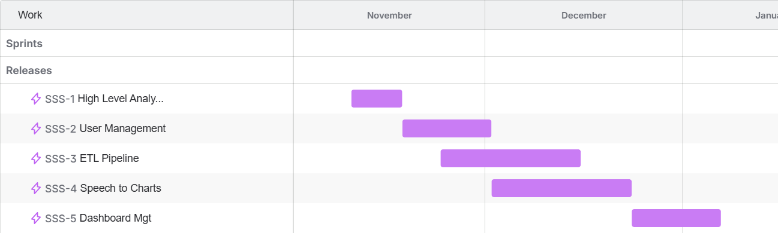

1. Introduction

1.1 Purpose
The purpose of this document is to specify the software requirements for the BI Voice Agent platform. This document provides a detailed description of the system’s functional requirements, system actors, and interaction scenarios, with a particular focus on Sprint 1, which covers the User Management domain.
This SRS serves as a foundational reference for modeling system use cases, defining system behavior, and guiding the design and implementation phases of the BI Voice Agent platform.

1.2 Project Scope
The BI Voice Agent platform is designed to enable voice-driven interaction with Business Intelligence systems. It allows users to manage workspaces, authenticate securely, and collaborate within a shared analytical environment before accessing advanced BI capabilities such as voice-based querying and dashboard analytics.
This specification focuses on high-level requirements related to user authentication, workspace management, role-based access control, and collaboration features, which form the backbone of the platform.

1.2.1 High-Level Requirements

• Authentication
This requirement provides secure access to the BI Voice Agent platform. The system allows users to authenticate using valid credentials and ensures that only authorized users can access system functionalities. Authentication is mandatory for all user roles and serves as the entry point for interacting with dashboards, reports, and analytical features.

• Profile Management
The system allows authenticated users to view and manage their personal profile information. This includes updating basic details such as name, contact information, and account settings. Profile management ensures personalization while maintaining account security.

• Workspace Management
This functionality enables the Manager to create, configure, and manage workspaces. A workspace represents the logical boundary for dashboards, reports, members, and data sources. Workspace management ensures that analytical resources are organized and accessible only to authorized members.

• Member Management
The system allows the Manager to manage workspace members. This includes inviting users, assigning roles, and removing members when necessary. Member management ensures controlled collaboration and enforces role-based access within the workspace.

• Workspace Governance
This requirement defines rules and policies that control how the workspace operates. It includes managing access permissions, enforcing role boundaries, and ensuring that shared dashboards and reports follow governance constraints defined by the Manager.

• Upload Database
The system enables the Manager to upload and register databases or datasets that will be used for analytical purposes. Uploaded data becomes available for querying, analysis, and visualization within the workspace, forming the foundation of BI operations.

• Voice Query
This functionality allows users to interact with the system using spoken language. Voice input is captured, converted into text, and processed to generate analytical queries. This feature enables non-technical users to explore data intuitively without writing SQL queries.

• Analysis
The system provides analytical capabilities that allow Analysts to explore data, apply aggregations, filters, and metrics, and derive insights. This requirement supports interactive analysis using both traditional and AI-assisted approaches.

• Report Generation
The system allows users to generate reports based on analytical results. Reports present structured insights in a readable format and can be accessed by authorized users for review and decision-making purposes.

• Dashboard Management
This requirement enables the Manager to create, edit, and manage dashboards. Dashboards provide a visual representation of analytical data and can include charts, tables, and KPIs. Managed dashboards can be shared with other workspace members.

• Access Shared Dashboard
The system allows authorized users to access dashboards shared within the workspace. This ensures that Analysts, Executives, and Dashboard Viewers can consume insights without modifying dashboard content

1.2.2 Actors

The BI Voice Agent system defines the following actors based on the high-level use case diagram:

1. Manager
The Manager is the owner of the workspace and holds full administrative control.
Responsibilities:
- Manage workspaces and workspace settings
- Upload databases
- Manage members and assign roles
- Create and manage dashboards
- Perform voice queries
- Access reports and analysis
- Manage personal profile and authentication

2. Analyst
The Analyst is a workspace member responsible for analyzing data and generating insights.
Responsibilities:
- Perform data analysis
- Generate and view reports
- Access shared dashboards
- Authenticate and manage personal profile

3. Executive
The Executive is a high-level consumer of insights with read-only analytical access.
Responsibilities:
- View reports
- Access shared dashboards
- Authenticate and manage personal profile

4. Report Viewer
The Report Viewer focuses on consuming reports generated by the system.
Responsibilities:
- View reports
- Authenticate to access reporting features

5. Dashboard Viewer
The Dashboard Viewer is responsible for viewing dashboards shared within the workspace.
Responsibilities:
- Access shared dashboards
- Authenticate to view dashboard content

6. Common User
The Common User represents shared behavior across all authenticated users.
Responsibilities:
- Authenticate into the system
- Manage personal profile information

2. Overall Description

2.1 Product Perspective
The BI Voice Agent platform described in this document is a new, standalone system designed to enable voice-based interaction with Business Intelligence platforms. The system is built as a modular, service-oriented solution that integrates speech processing, AI-based reasoning, and analytical data platforms.
The BI Voice Agent is not part of an existing product family, nor is it intended to replace a specific commercial BI tool. Instead, it complements traditional BI systems by providing an intuitive voice-driven interface that simplifies data exploration and decision-making for non-technical users.

2.2 Product Features
• User and Workspace Management

- Create and manage workspaces.
- Invite users and assign roles (Manager, Analyst, Executive).
- Manage workspace members and permissions.

• Authentication and Profile Management

- Secure user authentication with role-based access.
- Email verification and session management.
- Profile viewing and editing for all users.
• Voice-Based Querying

- Allow users to submit analytical questions using voice input.
- Convert speech to text and process it for analysis.
- Enable natural language interaction without SQL knowledge.
• Data Upload and Integration

- Upload and register analytical databases.
- Prepare data for querying and visualization.
• Data Analysis

- Perform analytical operations such as filtering, aggregation, and trend analysis.
- Support interactive analysis for Analysts.

• Report Generation
- Generate structured analytical reports.
- Allow authorized users to view and consume reports.

• Dashboard Management
- Create and manage dashboards.
- Share dashboards with workspace members.

• Access Shared Dashboards
- Allow Executives and Viewers to access shared dashboards.
- Ensure read-only access for non-administrative users.

2.3 User Classes and Characteristics
This section describes the different classes of users interacting with the BI Voice Agent system, along with their main characteristics, responsibilities, and access levels. Each user class is defined based on its role within the workspace and the functionalities it can access.

2.3.1 Manager
The Manager is the primary administrative user and the owner of the workspace. This user class is responsible for configuring and governing the workspace environment and managing its members.
Characteristics:
- Has full administrative privileges within the workspace.
- Possesses decision-making authority over data sources, dashboards, and access control.
- Typically represents a business owner, team leader, or BI administrator.
System Access:
- Workspace management
- Member management and role assignment
- Database upload and integration
- Dashboard creation and management
- Voice-based querying
- Reports and analysis
- Authentication and profile management

2.3.2 Analyst
The Analyst is a technical or semi-technical user focused on data exploration and insight generation. Analysts use the system to perform in-depth analysis without managing workspace settings.
Characteristics:
- Skilled in data analysis and interpretation.
- Does not have administrative permissions.
- Works within the boundaries defined by the Manager.
System Access:
- Data analysis features
- Report generation and viewing
- Access to shared dashboards
- Authentication and profile management

2.3.3 Executive
The Executive is a high-level stakeholder who consumes insights for strategic decision-making. This user class focuses on reviewing results rather than performing analysis.
Characteristics:
- Non-technical or business-oriented user.
- Requires quick access to summarized insights.
- Limited interaction with system configuration.
System Access:
- View reports
- Access shared dashboards
- Authentication and profile management

2.3.4 Report Viewer
The Report Viewer is a user role dedicated to viewing and consuming reports generated by the system.
Characteristics:
- Read-only access to analytical reports.
- Does not perform analysis or data manipulation.
- Often represents external or internal stakeholders.
System Access:
- View reports
- Authentication

2.3.5 Dashboard Viewer
The Dashboard Viewer focuses on accessing and viewing dashboards shared within the workspace.
Characteristics:
- Read-only user.
- Uses dashboards for monitoring KPIs and performance indicators.
- No permission to modify dashboards or data.
System Access:
- Access shared dashboards
- Authentication

2.3.6 Common User
The Common User represents shared behavior across all authenticated users in the system.
Characteristics:
- Represents common system functionality available to all roles.
- Ensures consistent access to core services.
System Access:
- Authentication
- Profile management

3. System Features

3.1 Functional Requirements

3.1.1 Authentication and Account Management

REQ-01: Sign Up
The system shall allow any user to create a new account using a valid email address and password.
- Actors: Manager, Analyst, Executive
- Category: Authentication
Sub-requirements:
- REQ-01.1: The system shall display a registration form requesting name, email, and password.
- REQ-01.2: The system shall validate the email format and password strength.
- REQ-01.3: The system shall prevent account creation if the email already exists.
- REQ-01.4: If the user signs up as a Manager, the system shall automatically create a Workspace linked to the account.

REQ-02: Email Verification
The system shall verify the identity of newly registered users through an email verification process.
- Actors: All Users
- Category: Authentication
Sub-requirements:
- REQ-02.1: The system shall send a verification email upon successful registration.
- REQ-02.2: The system shall activate the account only after successful verification.
- REQ-02.3: The system shall prevent unverified users from logging in.
- REQ-02.4: The system shall allow resending the verification email if the link expires.

REQ-03: Login
The system shall allow users to log in using valid credentials.
- Actors: Manager, Analyst, Executive
- Category: Authentication
Sub-requirements:
- REQ-03.1: The system shall validate the entered email and password.
- REQ-03.2: The system shall ensure the account is verified and not suspended.
- REQ-03.3: The system shall create an authenticated session (JWT or session token).
- REQ-03.4: The system shall redirect users based on their role:
  - Manager → Workspace Dashboard
  - Analyst / Executive → Shared Dashboards

REQ-04: Logout
The system shall allow users to securely terminate their session.
- Actors: All Users
- Category: Authentication
Sub-requirements:
- REQ-04.1: The system shall invalidate the active session or authentication token.
- REQ-04.2: The system shall clear session data from cache or memory.
- REQ-04.3: The system shall redirect the user to the login page.

3.1.2 Profile Management
REQ-05: Manage Profile
The system shall allow users to view and update their personal profile information.
- Actors: All Users
- Category: User Management
Sub-requirements:
- REQ-05.1: The system shall display current profile information.
- REQ-05.2: The system shall allow editing personal data (name, photo, contact info).
- REQ-05.3: The system shall validate updated information before saving.
- REQ-05.4: The system shall confirm successful updates.

REQ-06: Deactivate My Account
The system shall allow users to deactivate their own account.
- Actors: All Users
- Category: User Management
Sub-requirements:
- REQ-06.1: The system shall request confirmation before deactivation.
- REQ-06.2: The system shall change account status to “Deactivated”.
- REQ-06.3: The system shall terminate all active sessions.
- REQ-06.4: Deactivated users shall not be able to log in.

3.1.3 Workspace Management
REQ-07: Edit Workspace Information
The system shall allow the Manager to update Workspace details.
- Actors: Manager
- Category: Workspace Management
Sub-requirements:
- REQ-07.1: The system shall display current Workspace information.
- REQ-07.2: The system shall allow editing Workspace name and description.
- REQ-07.3: The system shall validate updated data.
- REQ-07.4: The system shall save and apply changes immediately.

REQ-08: View Workspace Members List
The system shall allow users to view all members within the Workspace.
- Actors: Manager, Analyst, Executive
- Category: Workspace Management
Sub-requirements:
- REQ-08.1: The system shall retrieve Workspace members from the database.
- REQ-08.2: The system shall display member name, email, role, and status.
- REQ-08.3: Access shall be restricted to members of the Workspace only.

REQ-09: Invite Members
The system shall allow the Manager to invite new members via email.
- Actors: Manager
- Category: Workspace Management
Sub-requirements:
- REQ-09.1: The system shall allow the Manager to enter an email and select a role.
- REQ-09.2: The system shall validate email uniqueness.
- REQ-09.3: The system shall send an invitation email.
- REQ-09.4: The system shall track invitation status.

REQ-10: Assign Roles
The system shall allow the Manager to assign or modify member roles.
- Actors: Manager
- Category: Access Control
Sub-requirements:
- REQ-10.1: The system shall display available roles.
- REQ-10.2: The system shall apply role changes immediately.
- REQ-10.3: Updated permissions shall take effect without re-login when possible.

REQ-11: Manage Members
The system shall allow the Manager to remove members from the Workspace.
- Actors: Manager
- Category: Workspace Management
Sub-requirements:
- REQ-11.1: The system shall request confirmation before removal.
- REQ-11.2: The system shall revoke Workspace access.
- REQ-11.3: The system shall terminate active sessions of the removed member.

REQ-12: Suspend Member
The system shall allow the Manager to temporarily suspend a member.
- Actors: Manager
- Category: Access Control
Sub-requirements:
- REQ-12.1: The system shall mark the member as “Suspended”.
- REQ-12.2: Suspended members shall be prevented from logging in.
- REQ-12.3: Active sessions shall be invalidated immediately.

REQ-13: Accept Invitation
The system shall allow invited users to join a Workspace.
- Actors: Analyst, Executive
- Category: Workspace Management
Sub-requirements:
- REQ-13.1: The system shall validate the invitation token.
- REQ-13.2: New users shall be prompted to register before joining.
- REQ-13.3: Existing users shall join directly.
- REQ-13.4: The system shall assign the predefined role automatically.

4. Non-Functional Requirements
This section describes the non-functional requirements of the BI Voice Agent system. These requirements define the quality attributes, performance constraints, and operational characteristics that ensure the system operates efficiently, securely, and reliably, while providing a high-quality user experience.

4.1 Performance Requirements
- NFR-01: The system shall process voice input and return a response (SQL query or visualization) within an acceptable time frame.
- NFR-02: The system shall support concurrent users within a workspace without significant degradation in performance.
- NFR-03: The ETL pipeline shall ingest and process uploaded datasets efficiently, even for large-scale data sources.
- NFR-04: Analytical queries executed on ClickHouse shall return results with low latency suitable for interactive BI usage.

4.2 Scalability Requirements
- NFR-05: The system shall be horizontally scalable to support an increasing number of users, workspaces, and datasets.
- NFR-06: The data ingestion and streaming components shall scale independently based on workload.
- NFR-07: The architecture shall support future expansion, such as adding new AI models or analytics components without major system redesign.

4.3 Security Requirements
- NFR-08: The system shall enforce role-based access control (RBAC) to restrict functionality based on user roles (Manager, Analyst, Executive).
- NFR-09: All user authentication mechanisms shall follow secure standards, including encrypted password storage and secure session handling.
- NFR-10: Sensitive data, including credentials and tokens, shall be transmitted using secure communication protocols.
- NFR-11: Users shall only access data and dashboards associated with their authorized workspace.

4.4 Reliability and Availability
- NFR-12: The system shall maintain consistent operation during normal usage hours.
- NFR-13: In case of partial system failures (e.g., ETL service interruption), the system shall continue operating with graceful degradation.
- NFR-14: The system shall log errors and critical events to support monitoring and debugging.

4.5 Usability Requirements
- NFR-15: The system shall provide an intuitive and user-friendly interface suitable for both technical and non-technical users.
- NFR-16: Voice-based interaction shall be simple and require minimal user training.
- NFR-17: Dashboards and reports shall be presented in a clear and visually understandable manner.

4.6 Maintainability Requirements
- NFR-18: The system shall be modular, allowing individual components (ETL, AI modules, UI) to be maintained or upgraded independently.
- NFR-19: The codebase shall follow clear architectural and coding standards to facilitate future maintenance.
- NFR-20: System logs and monitoring data shall support issue diagnosis and system health tracking.

4.7 Compatibility and Integration
- NFR-21: The system shall integrate seamlessly with external BI tools such as Metabase.
- NFR-22: The system shall support integration with multiple database types through the ETL pipeline.
- NFR-23: The system shall be compatible with modern web browsers without requiring additional plugins.

4.8 Portability
- NFR-24: The system shall be deployable in different environments (development, testing, production).
- NFR-25: The system shall support containerized deployment to simplify setup and scalability.

4. System Requirements

Req-ID | Requirement Title | Category | Priority
REQ-1.1 | The system shall allow users to create an account using email and password. | Authentication | High
REQ-1.2 | The system shall verify newly registered users via an email verification link. | Authentication | High
REQ-1.3 | The system shall allow users to log in using valid credentials. | Authentication | High
REQ-1.4 | The system shall allow users to securely log out and terminate their session. | Authentication | Medium
REQ-1.5 | The system shall allow users to view and update their personal profile information. | User Management | Medium
REQ-1.6 | The system shall allow users to deactivate their own account and revoke access. | User Management | Medium
REQ-2.1 | The system shall automatically create a workspace when a Manager registers. | Workspace Management | High
REQ-2.2 | The system shall allow the Manager to edit workspace information. | Workspace Management | High
REQ-2.3 | The system shall allow all workspace members to view the list of workspace members. | Workspace Management | High
REQ-2.4 | The system shall allow the Manager to invite Analyst and Executive users via email. | Workspace Management | High
REQ-2.5 | The system shall allow invited users to accept workspace invitations. | Workspace Management | High
REQ-3.1 | The system shall allow the Manager to assign roles to workspace members. | Access Control | High
REQ-3.2 | The system shall allow the Manager to modify member roles. | Access Control | High
REQ-3.3 | The system shall allow the Manager to remove members from the workspace. | Workspace Management | High
REQ-3.4 | The system shall allow the Manager to suspend workspace members. | Access Control | Medium
REQ-4.1 | The system shall allow the Manager to upload structured databases or datasets. | Data Management | High
REQ-4.2 | The system shall process uploaded data through an ETL pipeline. | Data Processing | High
REQ-4.3 | The system shall store processed data in an analytical database. | Data Management | High
REQ-4.4 | The system shall track ETL execution status and metadata. | Data Processing | Medium
REQ-5.1 | The system shall allow users to submit analytical questions using voice input. | Voice Interaction | High
REQ-5.2 | The system shall convert voice input to text using speech-to-text processing. | Voice Interaction | High
REQ-5.3 | The system shall analyze user queries to determine analytical intent. | Analysis | High
REQ-5.4 | The system shall automatically generate SQL queries based on user intent. | Analysis | High
REQ-5.5 | The system shall validate generated SQL queries before execution. | Analysis | Medium
REQ-6.1 | The system shall generate interactive dashboards based on analytical queries. | Dashboard Management | High
REQ-6.2 | The system shall allow the Manager to manage dashboards. | Dashboard Management | High
REQ-6.3 | The system shall allow Analysts and Executives to access shared dashboards. | Dashboard Access | High
REQ-6.4 | The system shall allow users to generate and view analytical reports. | Reporting | Medium
REQ-6.5 | The system shall allow users to export reports in common formats. | Reporting | Medium

5. Requirements modeling

- Basic UML Diagrams

System features (use case specifications - Sequence Diagrams):
• User management

Field | Description
Requirement ID | R-01
Requirement Name | Sign Up
Actors | Manager – Analyst – Executive
Preconditions | 1- The email address must not already exist in the system2- The user must have a valid email address
Main Flow | 1. The user opens the Sign-Up page.2. The system displays the registration form.3. The user enters the required information: name, email, and password.4. The system validates the input data (email format, password strength, required fields, etc.).5. The system checks whether the email address already exists in the system.6. The system creates a new user account.7. If the user is a Manager, the system automatically creates a Workspace linked to their account.8. The system sends a verification email to the user.9. The system displays a confirmation message:"Your account has been created. Please check your email to complete the verification process."
Alternative Flows | A1 - Email Already Exists1. The user clicks the “Create Account” button.2. The system detects that the email address is already registered.3. The system displays an error message:"This email address is already in use."A2 - Invalid Password1. The user submits the registration form.2. The system identifies that the password does not meet security requirements.3. The system displays an error message:"The password does not meet the required criteria."
Postconditions | 1. A new account is successfully created (Manager, Analyst, or Executive).2. If the user is a Manager, a Workspace is automatically created.3. A verification email is sent to the user

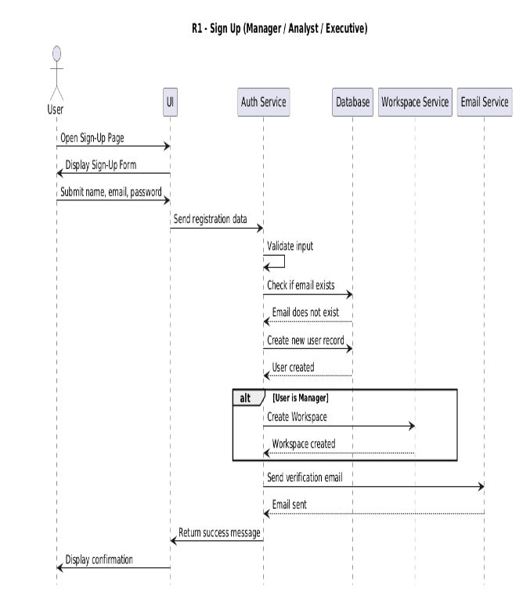

Field | Description
Requirement ID | R-02
Requirement Name | Email verification
Actors | Manager – Analyst – Executive
Preconditions | 1. User has completed Sign Up2. User account is in Unverified state
Main Flow | 1. User checks their email inbox2. User opens the verification email3. User clicks the verification link4. System receives the verification request5. System validates the verification token6. System activates the user account7. System displays: “Your account has been successfully verified. You can now log in.”
Alternative Flows | A1 - Expired Token1. User clicks the link2. System detects the token is expired3. System displays: “Verification link expired.”4. System offers “Resend verification email.”A2 - Already Verified1. User clicks the link2. System detects the account is already activated3. System displays: “Your account is already verified.”
Postconditions | 1. User account is activated2. User can log in to the system3. Account status updated to Activated in the database

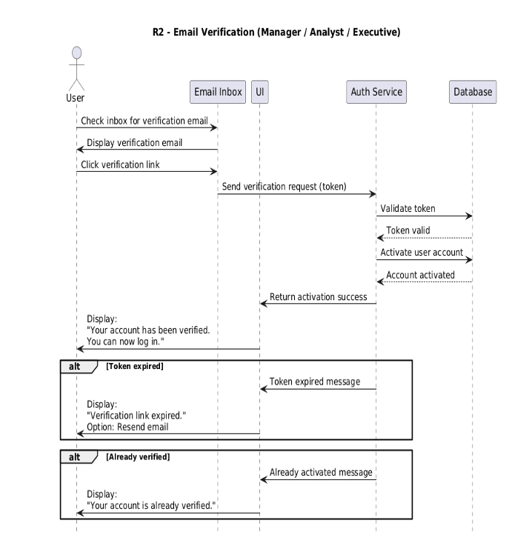

Field | Description
Requirement ID | R-03
Requirement Name | Login
Actors | Manager – Analyst – Executive
Preconditions | 1. The user must already have a registered account in the system User2. The user's account must be verified via email
Main Flow | 1. The user opens the Login page2. The system displays the login form3. The user enters their email and password4. The user clicks the “Login” button5. The system validates the provided credentials6. The system checks for a matching account in the database7. The system verifies that the account is activated and not suspended8. If the credentials are correct, the system creates a login session (Session or JWT Token)9. The system redirects the user to the appropriate landing page based on their role: • Manager : Workspace Dashboard • Analyst / Executive : Shared Dashboard10. The system displays a success message or directly redirects the user to their dashboard
Alternative Flows | A1 - Invalid Credentials1. The user enters an incorrect email or password2. The system displays:“Invalid login credentials.”A2 - Account Not Verified1. The user attempts to log in before email verification2. The system displays:“Please verify your email before logging in.”A3 - Account Suspended1. The system checks the user’s status2. The system detects that the account is suspended by the Manager3. The system displays:“Your account is suspended. You cannot log in.”
Postconditions | 4. User is successfully authenticated5. A session (or JWT Token) is generated6. User is redirected to the correct landing page according to their role

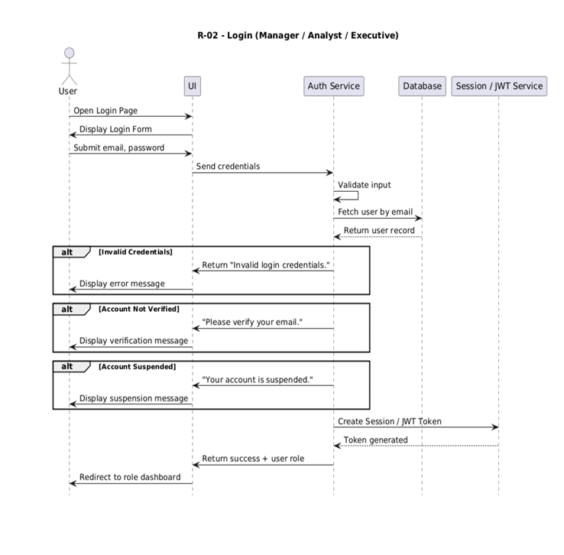

Field | Description
Requirement ID | R-04
Requirement Name | Logout
Actors | Manager – Analyst – Executive
Preconditions | 1. The user must be currently logged in2. A valid session or authentication token must exist
Main Flow | 1. The user clicks the “Logout” button2. The system receives the logout request3. The system invalidates the active session or authentication token4. The system clears any session-related data stored in memory or cache5. The system redirects the user to the login page or public home page6. The system displays a confirmation message: a. “You have been logged out successfully.”
Alternative Flows | A1 - Session Already Expired1. The user attempts to log out2. The system detects that the session has already expired3. The system redirects the user to the login page without showing an error message
Postconditions | 1. The current user session is invalidated2. The user is no longer authenticated3. No protected actions can be performed until the user logs in again

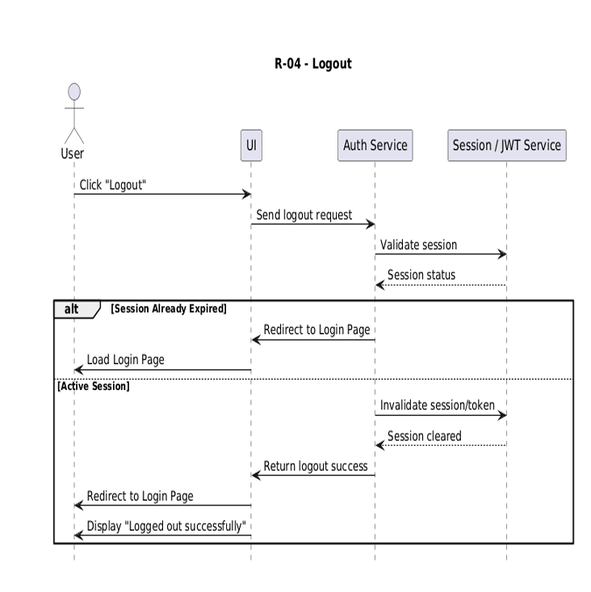

Field | Description
Requirement ID | R-05
Requirement Name | Manage Profile
Actors | Manager – Analyst – Executive
Preconditions | 1. User is logged in2. Account is active
Main Flow | 1. User opens the Profile page2. System retrieves and displays profile info3. System shows editable fields (name, photo, phone…)4. User updates fields and clicks Save5. System validates updated data6. System updates the database record7. System shows success message
Alternative Flows | A1 - Invalid Data1. User clicks Save2. System detects invalid fields3. System displays: “Invalid profile information.”
Postconditions | 1. The current user session is invalidated2. The user is no longer authenticated3. No protected actions can be performed until the user logs in again

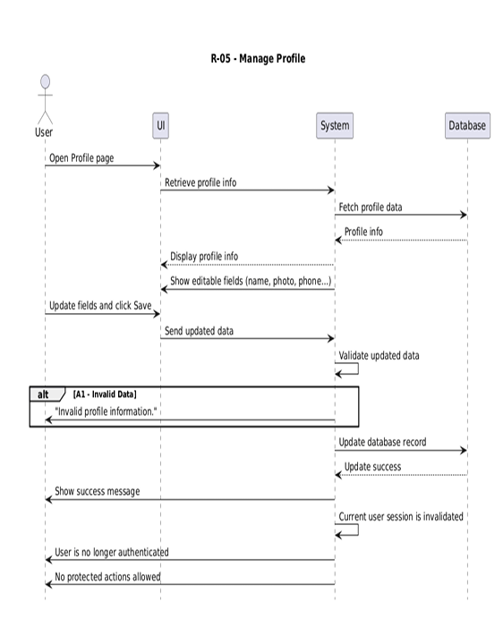

Field | Description
Requirement ID | R-06
Requirement Name | Deactivate My Profile
Actors | Manager – Analyst – Executive
Preconditions | 1. User is logged in
Main Flow | 1. User opens Account Settings2. System displays account management options including "Deactivate Account"3. User selects "Deactivate Account"4. System shows a confirmation warning5. User confirms the request6. System verifies the user's identity7. System sets account status to "Deactivated"8. System terminates active sessions9. System shows a success message
Alternative Flows | A1 - User Cancellation1. User clicks "Deactivate Account"2. System shows confirmation3. User selects "Cancel"4. System returns to settings unchanged
Postconditions | 1. Account is deactivated2. User cannot log in unless reactivation is supported3. All sessions are terminated

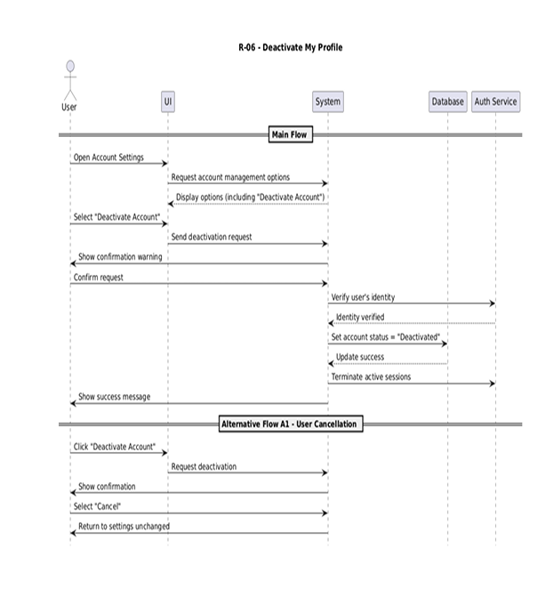

Field | Description
Requirement ID | R-07
Requirement Name | Edit Workspace Info
Actors | Manager
Preconditions | 1. manager is logged in
Main Flow | 1. Manager opens Workspace Settings2. System displays current workspace info3. Manager clicks “Edit Workspace Info”4. System shows editable fields5. Manager updates fields and clicks Save6. System validates updated data7. System updates the database8. System displays success message
Alternative Flows | A1 - Invalid Data1. Manager clicks Save2. System detects invalid data3. System shows: “Invalid input data.”
Postconditions | 1. Workspace info updated2. Updated values displayed in manager UI

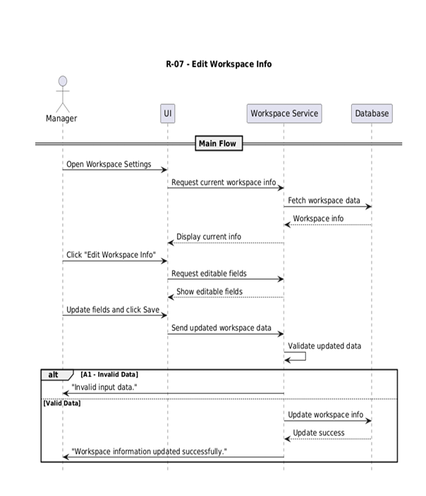

Field | Description
Requirement ID | R-08
Requirement Name | View Workspace Members List
Actors | Manager – Analyst – Executive
Preconditions | 1. user is logged in2. User is a member of the current workspace
Main Flow | 1. User opens Workspace Members page2. System verifies permission to view members3. User stays on the same page4. System retrieves workspace members from the database5. System displays the list (name, email, role, status)
Alternative Flows
Postconditions | 1. Members list successfully retrieved2. User can view workspace members

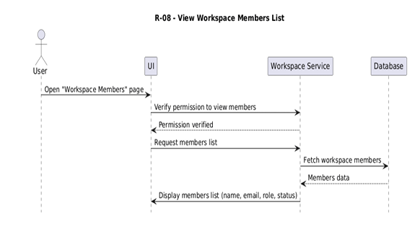

Field | Description
Requirement ID | R-09
Requirement Name | Invite Members
Actors | Manager
Preconditions | 1. manager is logged in2. New member’s email is valid
Main Flow | 1. Manager opens Members Management page2. System shows “Invite Member” option3. Manager clicks “Invite Member”4. System displays invitation form5. Manager enters email and selects role6. System validates email and role7. System creates invitation record8. System sends invitation email9. System shows success message
Alternative Flows | A1 - Invalid Email:1. Manager enters invalid email.2. System rejects it.3. System shows: “Invalid email address.”A2 - Already Invited1. Manager enters previously invited email2. System detects existing invitation3. System shows: “Invitation already sent.”A3 - User Already Exists1. Manager enters email of existing user2. System detects existing account3. System shows: “User already exists.”
Postconditions | 1. New invitation is created2. Invitation email is sent

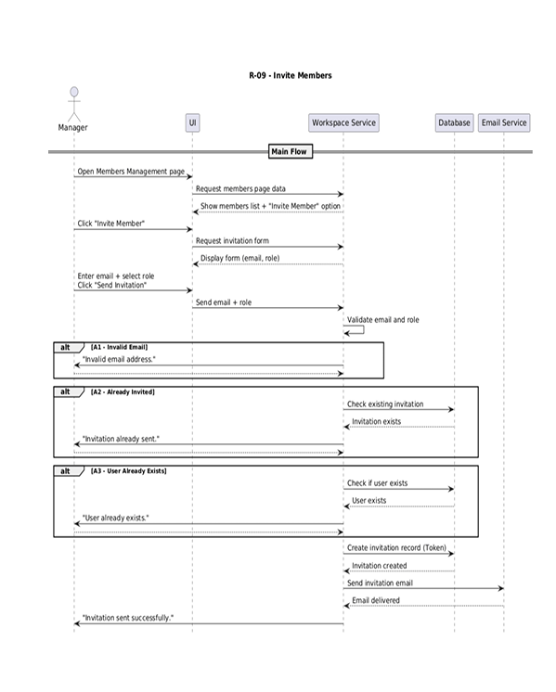

Field | Description
Requirement ID | R-10
Requirement Name | Assign Roles
Actors | Manager
Preconditions | 1. manager is logged in2. Member exists in the workspace
Main Flow | 1. Manager opens Members Management page2. System displays members and roles3. Manager selects a member4. System shows available actions including Change Role5. Manager selects new role6. System validates the role7. System updates the role in the database8. System shows success message
Alternative Flows | A1 - Member Not Found1. Manager selects a member2. System detects the member does not exist3. System shows: “Member not found.”
Postconditions | 1. Role is updated in the database2. New role appears immediately in the UI

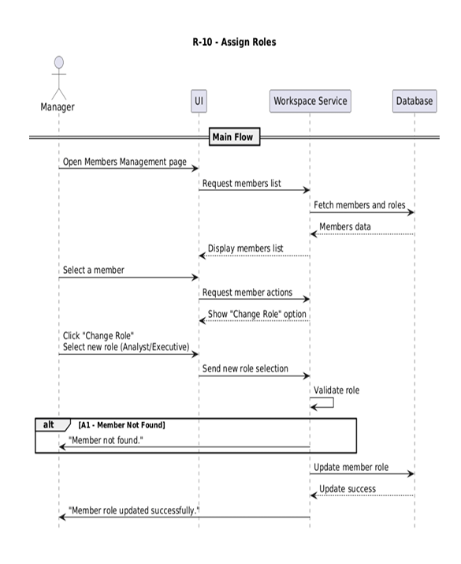

Field | Description
Requirement ID | R-11
Requirement Name | Remove Members
Actors | Manager
Preconditions | 1. manager is logged in2. Member exists in the workspace
Main Flow | 1. Manager opens Members Management page2. System displays members with a Remove option3. Manager selects a member and clicks “Remove”4. System shows confirmation dialog5. Manager confirms removal6. System verifies permissions7. System removes the member8. System terminates active sessions9. System shows success message
Alternative Flows | A1 - Cancel Removal1. System displays confirmation dialog2. Manager clicks “Cancel”3. System returns to Members Management with no changes
Postconditions | 1. Member is removed2. Member loses workspace access

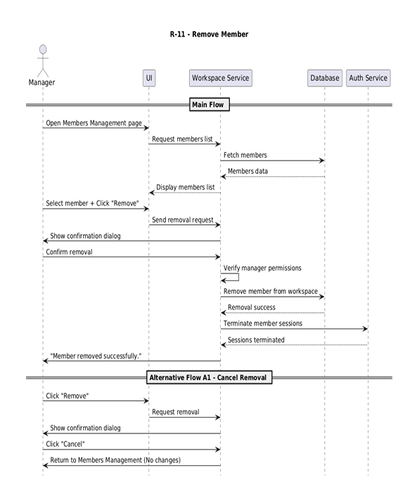

Field | Description
Requirement ID | R-12
Requirement Name | Suspend Member
Actors | Manager
Preconditions | 1. manager is logged in2. Member exists in the workspace
Main Flow | 1. Manager opens Members Management page2. System shows members with status (Active/Suspended)3. Manager selects a member and views details4. System shows “Suspend Member” option5. Manager clicks “Suspend Member”6. System shows confirmation with impact explanation7. Manager confirms8. System updates member status to Suspended9. System invalidates member's session10. System shows success message
Alternative Flows | A1 - Member Already Suspended1. Manager selects the member2. System detects status : Suspended3. System shows: “Member is already suspended.”
Postconditions | 1. Member is suspended2. Member cannot log in to the workspace3. Active sessions are terminated

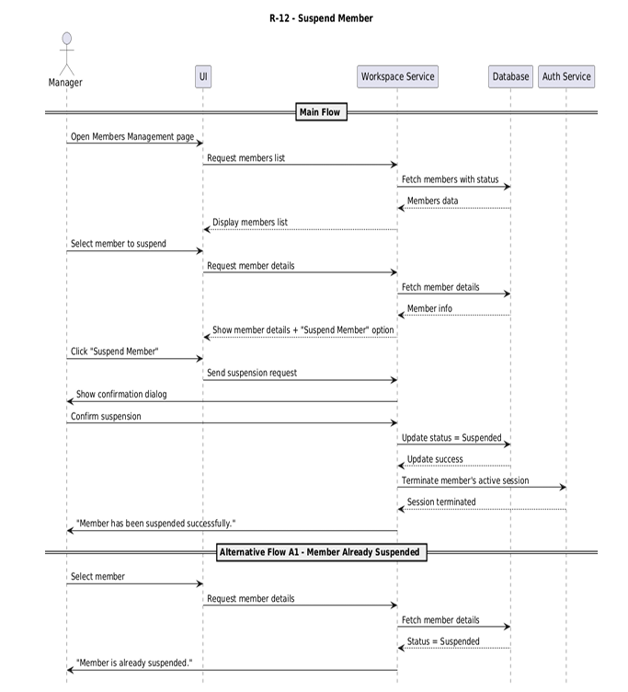

Field | Description
Requirement ID | R-13
Requirement Name | Accept Invitation
Actors | Analyst – Executive
Preconditions | 1. User has been invited by the manager2. User received the invitation email3. Invitation token is valid and unused
Main Flow | 1. User opens invitation email2. System shows “Join Workspace” link3. User clicks the link4. System validates token5. System checks invitation validity and usage6. System displays one of two options: • No account : Registration form • Existing account : Join button7. User: • New user : Register & Join • Existing user : Join Now8. System creates or links account9. System assigns the role10. System marks invitation as Used11. System displays success message
Alternative Flows | A1 - Invalid Link4. User clicks the link5. System checks invitation token6. Token is invalid7. System displays: “Invalid invitation link.”A2 - Invitation Expired1. User clicks the link2. System detects expired invitation3. System displays: “Invitation expired.”A3 - Invitation Already Used1. User opens the link2. System detects invitation status : Used3. System displays: “This invitation was already used.”
Postconditions | 1. User is added to the workspace2. Invitation is marked as Used3. User has the assigned role

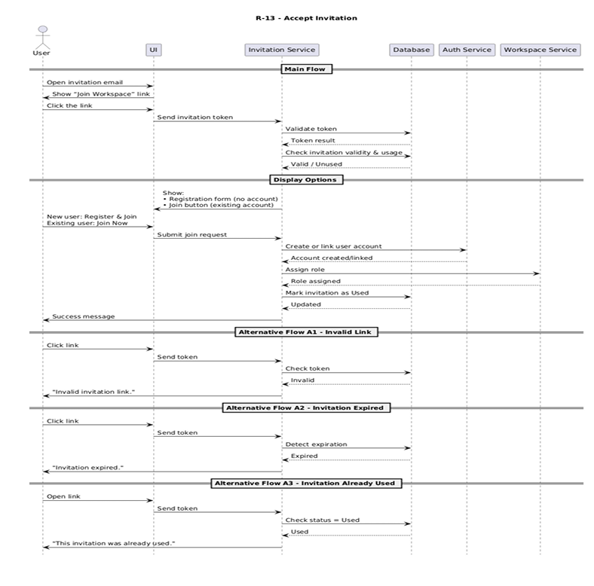

Class Diagram
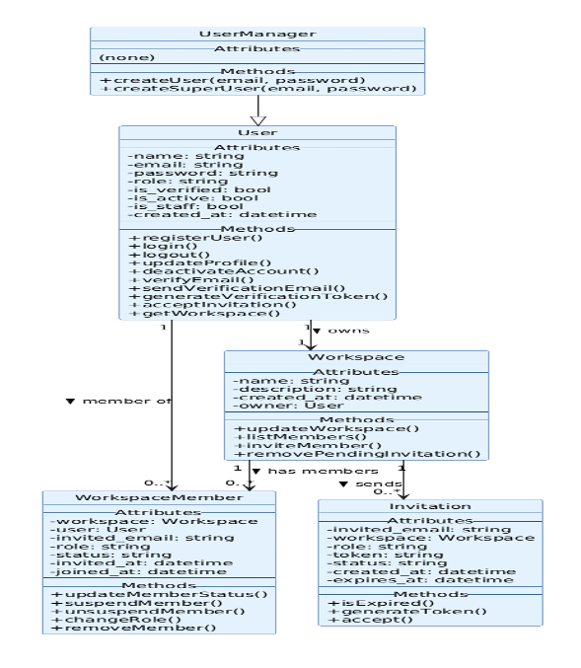

[1] ThoughtSpot — https://www.thoughtspot.com/
[2] Databricks AI/BI Genie — https://www.databricks.com/product/ai-bi/genie
[3] Microsoft Power BI — https://www.microsoft.com/en-us/power-platform/products/power-bi
[4] Vanna.AI — https://vanna.ai/
[5] Sequel.sh — https://sequel.sh/

